RA1911029010074

Sreelakshmi Nambiar

AIM- Implementing route summarization on cisco packet tracer

PROCEDURE- First take 4 routers and 4 PCs now connect them.

Assign IP addresses to each and connect them to the switches used assigning the PCs with the default gateway address

Noe configure all the routers statically so that the networks that are not neighbouring are also connected do this for all the routers

Now ping from one PC to confirm if the network is setup

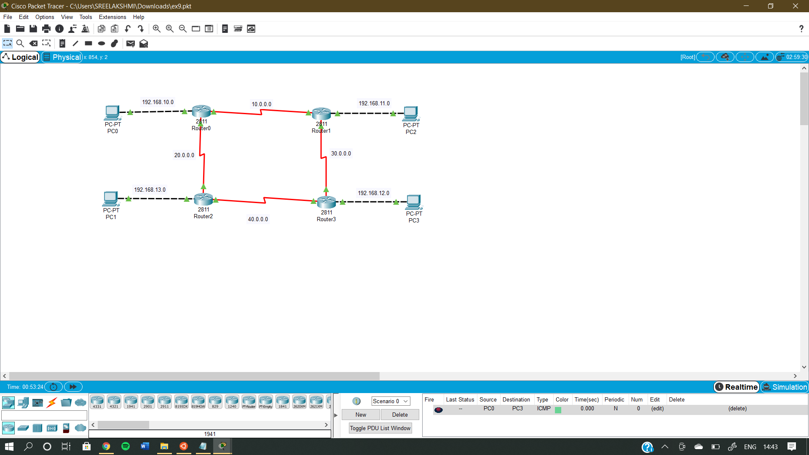

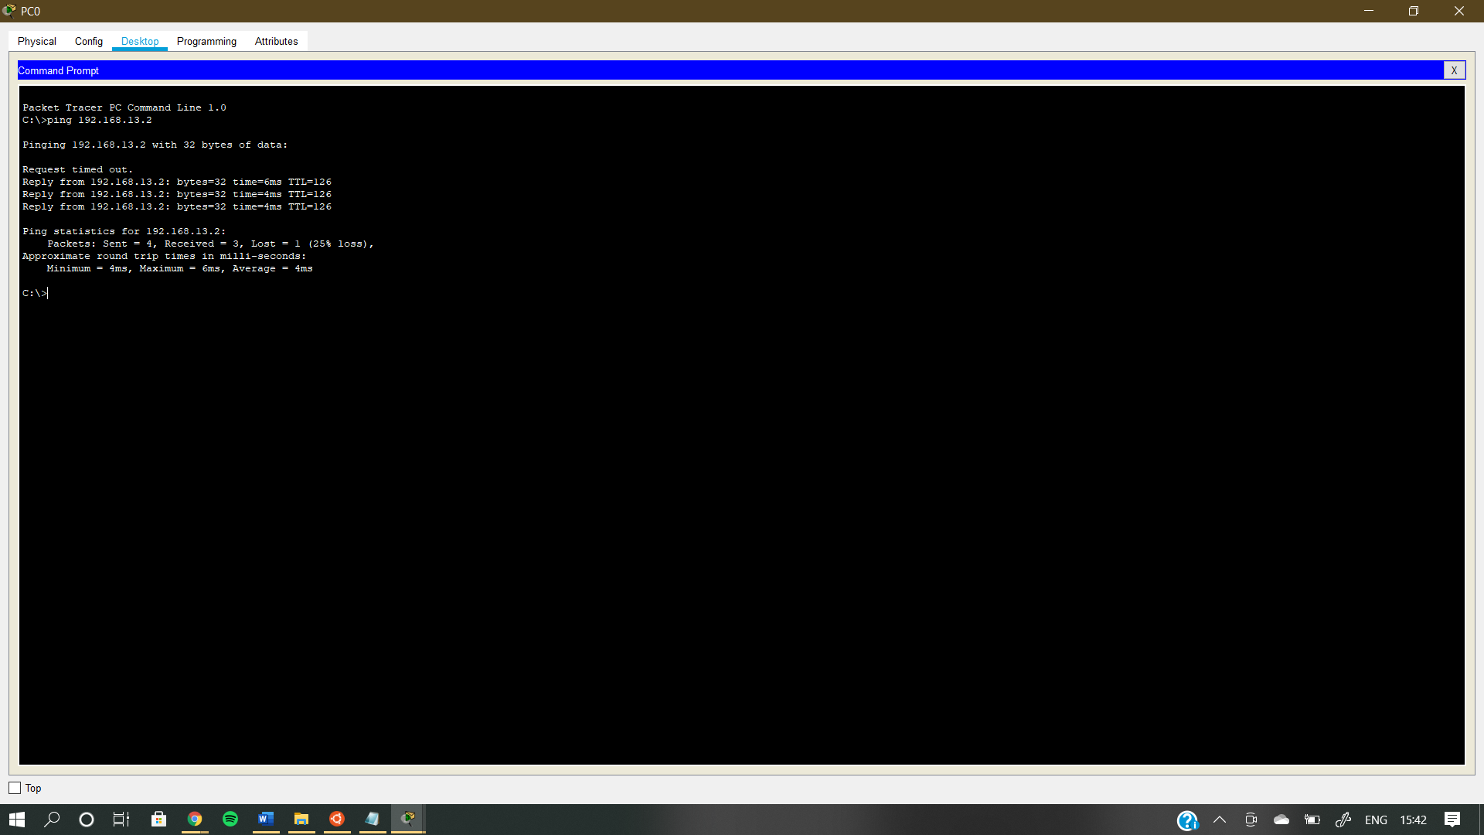

RESULT -Implemented route summarization on cisco packet tracer